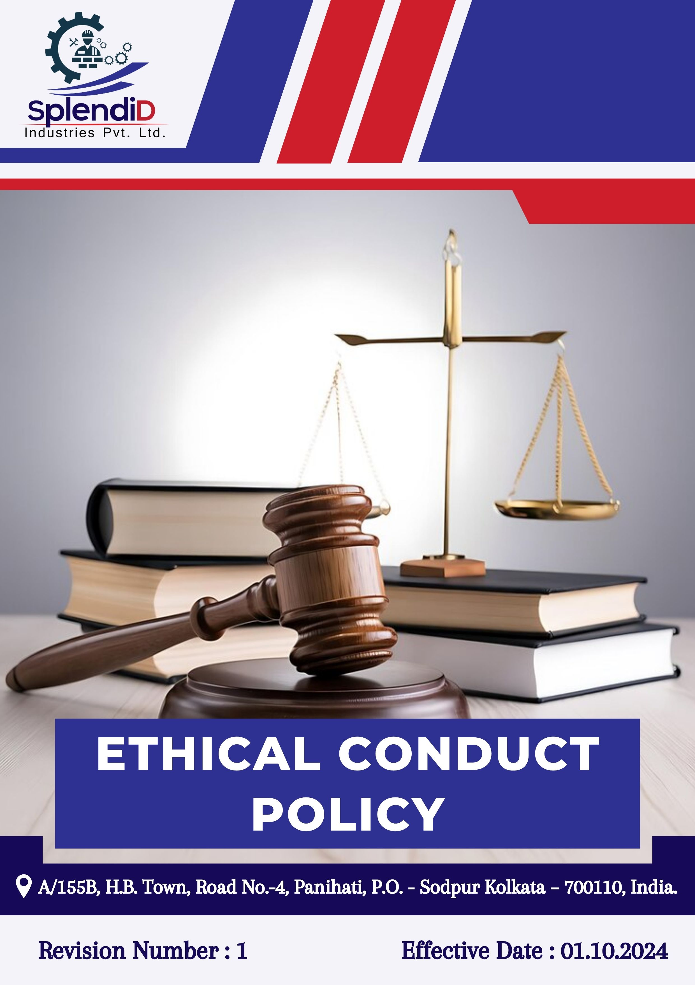

Table of Contents
Introduction 3
Scope 3
Policy Declaration 3
Key Focus Areas 4
Objectives and Targets 4
Targets in alignment with SDGs 6
Examples and Guidance 7
Continuous Improvement 10
Addressing Policy Violations 10
Responsibilities 11
Review Mechanism 12
Employee Acknowledgment Form 13

Introduction
At Splendid Industries Pvt. Ltd., we are committed to conducting our business with the highest standards of integrity, transparency, and professionalism. As a leading provider of architectural and industrial metal solutions, our reputation is built on engineering excellence, customer trust, and ethical responsibility. This Ethical Conduct Policy outlines the foundational principles that guide our actions and decisions across all levels of the organization, from design and fabrication to execution and client interaction.
Through this policy, we aim to promote a culture of ethical awareness, responsible conduct, and accountability. We are dedicated to ensuring that all employees and stakeholders act with fairness, honesty, and respect while complying with legal requirements and industry best practices. Our goal is to foster an environment where ethical growth, mutual respect, and responsible business practices are embedded in our day-to-day operations.

Scope
This Ethical Conduct Policy applies to all employees, officers, directors, and representatives of Splendid Industries Pvt. Ltd., as well as third-party partners such as contractors, consultants, suppliers, and vendors. It covers all business activities and interactions across departments and functions, including manufacturing, project execution, procurement, sales, and customer service, and governs relationships with clients, authorities, and industry partners.
Sr. No. | Site | Address
1 | Splendid Industries Pvt.Ltd. | A/155B, H.B. Town, Road No.-4, Panihati, P.O. - Sodpur Kolkata – 700110, India.

Policy Declaration
Splendid Industries Pvt. Ltd. is dedicated to conducting business with integrity, transparency, and compliance with all applicable laws. All employees and partners are expected to avoid conflicts of interest, refrain from bribery, corruption, and fraud, and maintain honesty in all dealings. We also provide a safe, retaliation-free channel for reporting any unethical behavior or violations of this policy. Violations will be taken seriously and may result in disciplinary action. Through this commitment, we aim to maintain trust, protect our reputation, and support sustainable growth.

Key Focus Areas
- Preventing Corruption: Strictly prohibit bribery, kickbacks, and any form of corrupt practices through clear policies, training, and enforcement.
- Conflict of Interest: Require disclosure and proper handling of personal or professional interests that may influence company decisions.
- Fraud: Prevent and detect fraud through internal controls, regular audits, and secure reporting mechanisms.
- Anti-Money Laundering: Comply with AML laws by verifying transactions, monitoring for suspicious activity, and training employees on red flags.
- Information Security: Safeguard sensitive data through robust cybersecurity measures, access controls, and regular employee awareness programs.
- Responsible Use of Company Assets: Use company resources efficiently and solely for legitimate business purposes, avoiding waste or misuse.

Objectives and Targets
The FY 2022-23 serves as the baseline for all ethical governance targets at Splendid Industries, including those related to business integrity, anti-corruption, conflict of interest, fraud prevention, and anti-money laundering. Progress will be measured against this baseline to ensure continuous improvement through years with the targets set for FY 2029-30.
- Preventing Corruption
- Maintain a zero-tolerance policy for bribery and corruption and ensure strict compliance with anti-corruption laws and company policies.
- Maintain inclusion and compliance of anti-bribery clauses into 100% of supplier and partner contracts by FY 2029-30.
- Train 100% of procurement and finance teams on anti-corruption policies annually.
- Maintain zero instances of corruption reported in annual audits.
- Conflict Of Interest
- Promote a culture of transparency, encouraging employees to avoid situations where personal interests could conflict with business interests.
- Ensure implementation of clear procedures for handling potential conflicts of interest fairly and impartially.
- Achieve 100% completion rate of annual conflict of interest disclosures by all managers by FY 2029-30.
- Fraud
- Provide annual training on identifying, preventing, and reporting fraud to all employees and encourage a culture of accountability, where fraudulent activities are promptly reported and addressed.
- Conduct fraud risk assessments across all functions annually.
- Maintain zero fraud - related incidents annually.
- To maintain the implementation of a fraud detection mechanism to monitor and flag suspicious activities, and hence achieve 0% of undetected fraudulent transactions by FY 2029-30.
- Anti-money Laundering
- Regularly monitor and audit financial transactions to detect any suspicious activity
- Maintain zero number of false positive alerts in AML monitoring systems.
- Screen 100% of high-risk third parties annually using AML compliance checks.
- Train 100% of finance and legal staff on AML procedures annually.
- Information Security
- Enforce stringent information security protocols to protect sensitive business, employee, and client data from unauthorized access, breaches, and cyber threats.
- Conduct mandatory annual cybersecurity training for 100% employees, covering data privacy, phishing prevention, and risk mitigation strategies.
- Ensure 100% compliance with information security audits conducted across all departments anually
- Maintain zero incidents of unauthorized data access and breaches through improved controls by FY 2029-30.

- Responsible Use of Company Assets
- Conduct annual audits to reduce misuse or waste of assets by 90%.
- Promote efficient and ethical use of company resources through awareness campaigns.
- Implement clear guidelines for personal use of company assets to avoid conflicts.

Targets in alignment with SDGs
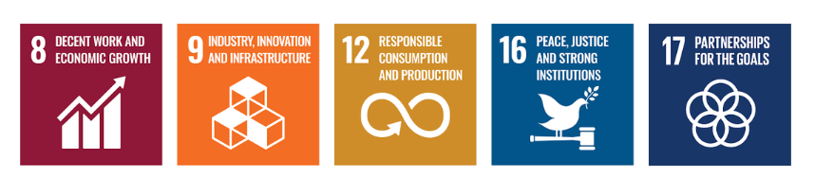

Examples and Guidance
To support consistent understanding and implementation of this Ethical Conduct Policy, the following topic-wise examples and guidance offer practical interpretations of expectations and actions:

- Preventing Corruption
- Example: A supplier offers a procurement executive luxury event tickets in return for favorable contract terms.
- Guidance: The executive must decline the offer and report it to the compliance officer. Accepting such gifts violates anti-corruption policies. Employees must maintain objectivity and transparency in all supplier dealings.
- Conflict of Interest
- Example: A project manager is asked to evaluate a vendor owned by their spouse.
- Guidance: The manager must disclose the relationship and recuse themselves from the selection process. All potential conflicts must be reported, and decisions must be made without personal bias or undue influence.

- Fraud
- Example: A finance team member notices duplicate invoices submitted by a vendor for payment.
- Guidance: The incident should be flagged and investigated immediately. Employees should report any financial irregularities through proper channels and ensure transactions are thoroughly reviewed.

- Anti-Money Laundering
- Example: A customer asks to divide a large transaction into smaller amounts to avoid reporting thresholds.
- Guidance: This is a red flag for potential money laundering. The transaction must be reported and flagged for review as per AML protocols. Employees must be trained to recognize and respond to suspicious financial behavior.

- Information Security
- Example: An employee accidentally leaves printed confidential client information in a public area.
- Guidance: The breach must be reported to IT and compliance immediately. Sensitive data must be securely stored and disposed of. Employees should follow data protection protocols at all times.

Continuous Improvement
At Splendid Industries Pvt. Ltd., Ethical Conduct practices are continuously enhanced to stay aligned with evolving regulations, industry standards, and emerging risks. A strong culture of integrity is embedded across all levels of the organization, ensuring transparency, accountability, and regulatory compliance.

- Ongoing Training & Awareness: Employees undergo annual training on key ethical topics, including anti-corruption, conflict of interest, fraud prevention, anti-money laundering (AML), and information security.
- Risk Assessments & Independent Audits: Regular internal reviews and third-party audits help identify potential ethical risks, evaluate policy effectiveness, and drive corrective actions.
- Collaborative Compliance Engagement: Active participation in industry forums and regulatory dialogues supports alignment with best practices and ethical norms.
- Advanced Monitoring & Reporting Systems: Secure digital tools and automated monitoring mechanisms strengthen fraud detection, compliance management, and incident reporting.
- Feedback & Transparency Culture: Open channels for feedback empower employees and stakeholders to share concerns or suggestions, driving continual ethical improvements.

Addressing Policy Violations
Splendid Industries Pvt. Ltd. maintains a zero-tolerance approach toward violations of its Ethical Conduct Policy. All suspected or confirmed breaches will be handled seriously, fairly, and in a timely manner to uphold the company’s values of integrity, transparency, and accountability.
- Reporting Violations: Employees are strongly encouraged to report any unethical or suspicious behaviour through appropriate channels, including direct supervisors, the internal compliance team, or the company’s confidential whistleblower system, which allows anonymous submissions without fear of retaliation.
- Investigation Process: All reported concerns will be promptly investigated by designated personnel or third-party experts, ensuring impartiality and strict confidentiality throughout the process. The identity of whistleblowers will be protected unless disclosure is legally required.
- Corrective Actions: When a violation is confirmed, the company will take appropriate disciplinary action based on the severity of the offense. This may include formal warnings, mandatory retraining, suspension, reassignment, or termination of employment. For example, an employee found accepting unauthorized payments from vendors may face immediate dismissal and legal prosecution.
- Protection from Retaliation: Retaliation in any form against whistleblowers or those cooperating with an investigation is strictly prohibited. Any individual found engaging in retaliatory behaviour will be subject to disciplinary consequences.

Responsibilities
At Splendid Industries Pvt. Ltd., upholding ethical conduct is a collective responsibility:
- Compliance Officer: Ensures implementation of ethical policies and compliance with anti-corruption, conflict of interest, fraud, and information security standards.
- HR Manager: Oversees employee training on ethical conduct, including anti-corruption and conflict-of-interest policies.
- IT Manager: Safeguards company and customer data through secure information systems.
- Internal Audit Team: Conducts audits to assess policy compliance and identify risks.
- Senior Management: Reviews ethical performance, allocates resources, and promotes a culture of integrity.

Review Mechanism
The Ethical Conduct Policy is reviewed annually by the Compliance Officer to ensure its continued relevance, effectiveness, and alignment with legal and regulatory requirements. Updates may be made based on audit findings, changes in applicable laws, employee feedback, or evolving business practices. Any revisions are communicated to all employees, and necessary training is provided to ensure awareness and compliance.

Effective Date: 01.10.2024
Next Review Date: 01.10.2025
Approved By:

Employee Acknowledgment Form
I acknowledge that I have received, read, and understood the Ethical Conduct Policy of Splendid Industries Pvt. Ltd. I to uphold the principles set forth in the policy, including preventing bribery and corruption, identifying and disclosing conflicts of interest, preventing fraud, complying with anti-money laundering regulations, and protecting confidential company and client information.
I understand that it is my duty to follow this policy in all professional conduct and to report any suspected violations or unethical behavior through the company’s confidential whistleblower system or other designated channels. I am aware that any breach of this policy may result in appropriate disciplinary action agree as per company guidelines.
By signing this declaration, I confirm my personal commitment to maintaining ethical behavior, accountability, and transparency in all my responsibilities at Splendid Industries Pvt. Ltd.

Employee Name  Employee ID  Date  Signature | :_______________________________  :_______________________________ :________________________________  : _______________________________

